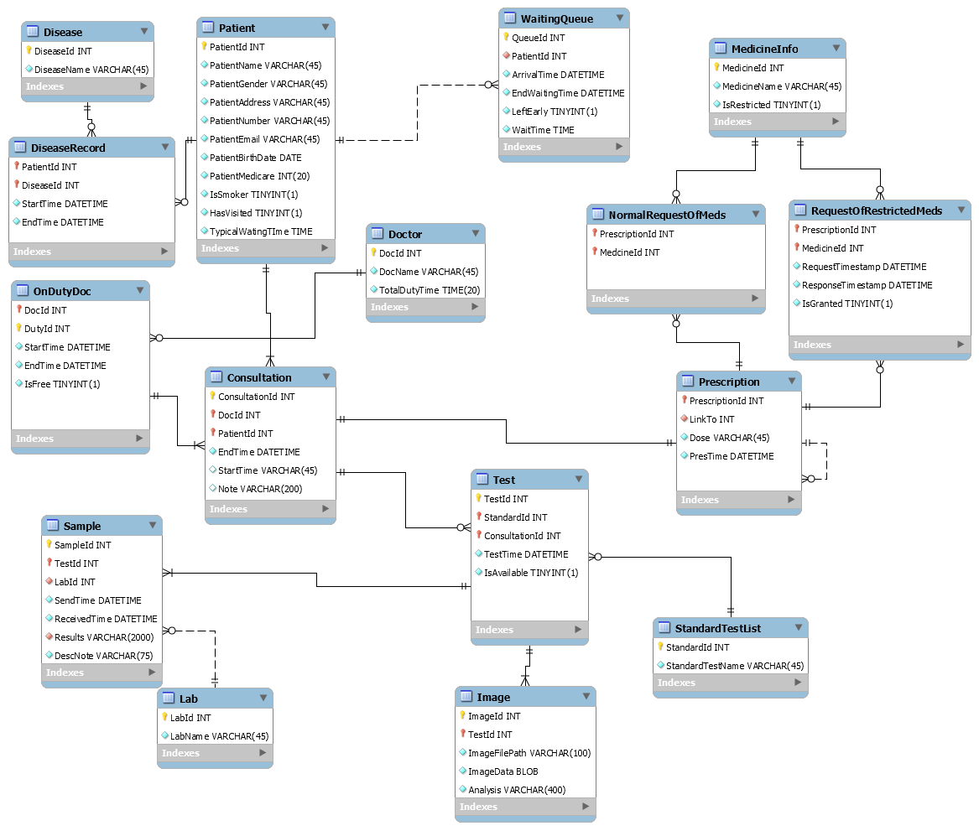
Data Dictionary

Entity 'Patient'
This is a table that holds patients’ information after registering into the system. Patients who have been to the clinic before will have data recorded in two extra attributes, which are ‘HasVisited’ and ‘TypicalTime’ and they can simply sign in by using their patient id and birthdate.
Attribute | Description
PatientId | This is the primary-key of entity ‘patient’. It is a unique integer for one specific patient and it is issued by the system once the patient has completed registration. Then next time the patient comes, he/ she can use it for signing in.
PatientName | The name of the patient, and it’s usually a string, e.g. ‘Benjamin Li’, varchar. Repetition is allowed.
PatientGender | The gender of the patient, Boolean. ‘1’ represents male and ‘0’ represents female.
PatientAddress | This field holds the address of patients, a string e.g. ‘746 Swanston St.’, varchar. Since some patients could be roommates, it’s not unique.
PatientNumber | The phone number of the patient. No longer than an eleven-digit number, but the data type is varchar.
PatientEmail | Holds the email address of the patient e.g. ‘jili@gmail.com’, varchar.
PatientBirthDate | The birthdate of the patient e.g. ‘1995-12-03’, date. After the registration, the birthdate will be used as password of the account. So, birthdate will then be converted into an 8-digit number e.g. ‘19951203’.
PatientMedicare | The unique 20-digit number of every patient, integer and unique.
IsSmoker | A Boolean value ‘0’ and ‘1’ means ‘Not a smoker’ and ‘Is a smoker’, respectively. This will help to build up the record of the patient.
HasVisited | A Boolean value ‘1’ and ‘0’ means ‘Has visited before’ and ‘has not visited before’, respectively. Those with the value ‘1’ need no registration and can simply sign in.
TypicalTime | This holds the data of how long a patient usually wait until their consultation starts. The information will be updated every few months according to the data from another entity ‘WaitingQueue’.

Entity 'DiseaseRecord'
A record of information about patients’ diseases, including the time when it is recorded(added) and when the disease is cured. Sometimes there could be no disease record of a patient so the foreign-key on this side is not mandatory.
Attribute | Description
PatientId | This is the first foreign-key and primary-key of entity ‘DiseaseRecord’. It is a unique integer for one specific patient and it links to the attribute ‘PatientId’ in entity ‘Patient’.
DiseaseId | This is the second foreign-key and primary-key of entity ‘DiseaseRecord’. It is a unique integer for a type of disease and it links to the attribute ‘DiseaseId’ in entity ‘Disease’ which holds more than 300 different names of diseases. Together PatientId and DiseaseId help to identify a unique row of data.
StartTime | The time when a disease is recorded e.g. ‘2017-04-22 08:00:00’, datetime.
EndTime | The time when a disease is cured e.g. ‘2017-05-21 09:00:00’, datetime.

Entity 'Disease'
A table that holds more than 300 different normative names of diseases. It should be static.
Attribute | Description
DiseaseId | This is the primary-key of entity ‘Disease’, integer.
DiseaseName | Data type is varchar, the name of the disease e.g. ‘Migraine’. It contains 300 standard diseases.

Entity 'WaitingQueue'
After the registering/signing in, patients will come to the queue and wait for the consultation. The entity includes the arrival time, consultation starting time and if the patient leaves before the consultation starts. It is noteworthy that a patient can come to the queue and leave and come again, so each time the patient should be issued a unique waiting number which in this case is ‘QueueId’.
Attributes | Description
QueueId | This is the only primary-key of entity ‘WaitingQueue’, integer.
PatientId | The foreign-key refers to the attribute ‘PatientId’ in entity ‘Patient’, integer.
ArrivalTime | The time when a patient gets into the queue e.g. ‘2018-07-10 10:00:00’, datetime. It can be used to calculate the typical arrival time and waiting time.
EndWaitingTime | The time when patients stop waiting and are called for the consultation e.g. ‘2018-07-10 11:00:00’, datetime. It’s also recorded for counting the typical arrival time.
LeftEarly | A Boolean value ‘0’ and ‘1’ means ‘hasn’t left’ and ‘has left’, respectively. This will help to build a record of whether the patient leaves and if they have left then the system will ignore them and call the next patient.
WaitTime | Waiting time is the gap between ‘EndWaitingTime’ and ‘ArrivalTime’. Every few months, the average value of it will be updated to the ‘TypicalTime’ in ‘Patient’ entity.

Entity 'Doctor'
The collection of all doctors, whether they are on duty or not. Currently, there are 20 doctors in this clinic, and the number is expected to be around 100 doctors in the clinic over the life of the clinic.
Attribute | Description
DocId | This is the primary-key of entity ‘Doctor’, a unique integer.
DocName | This is the name of the doctor and it is a repeatable varchar.
TotalDutyTime | Holds the amount of doctor’s duty time so that the clinic can pay them by hour. It is calculated and accumulated from a doctor’s daily working data.

Entity 'OnDutyDoctor'
Doctors who are on the duty. Including work time statistics and is he or she now free to have another consultation. Every day, there will be 10 doctors on duty to make consultations for patients.
Attribute | Description
DocId | This is the foreign-key as well as the second primary-key of the entity ‘OnDutyDoctor’ and it links to the attribute ‘DocId’ of the entity ‘Doctor’.
DutyId | This is the primary-key of entity ‘OnDutyDoctor’, a unique integer. Every time a doctor is on duty will be issued an id, regardless of whether the doctor is the same person.
StartTime | This is the time when the doctor starts working e.g. ‘2017-04-22 08:00:00’, datetime.
EndTime | This is the time when the doctor stop working e.g. ‘2017-05-21 09:00:00’, datetime.
IsFree | This is a Boolean value indicating whether the doctor is free or not and it’s controlled by the doctor. The system will read the data and decide whether to let the next patient start consultation or not.

Entity 'Consultation'
When a doctor becomes free, a consultation starts. This entity records the time of start and end of each consultation along with a note. A prescription for the patient and decide whether they need tests to be performed is also recorded here. When a consultation is over, the doctor will signal to the system to call the next patient. It’s expected that there will be approximately 200 million consultations throughout the clinic’s life.
Attributes | Description
ConsultationId | This is the first primary-key of entity ‘Consultation’, a unique integer.
DocId | This is the first foreign-key and second primary-key of the entity ‘Consultation’ and it links to the attribute ‘DocId’ of the entity ‘Doctor’, integer.
PatientId | This is the second foreign-key and third primary-key of the entity ‘Consultation’ and it links to the attribute ‘PatientId’ of the entity ‘Patient’, integer.
StartTime | The time when a doctor and a patient start the consultation e.g. ‘2018-07-10 11:00:00’, datetime. It’s the third foreign-key links to the attribute ‘ConsultationStartTime’ in entity of ‘WaitingQueue’. And they share the same value.
EndTime | This is the time when the consultation ends e.g. ‘2017-05-21 09:00:00’, datetime. When the doctor records the end time, he will inform the system to call the next patient.
Note | A set of notes that the doctor records for this certain consultation e.g. ‘The patient gets psychosis that he always thinks that he is an apple.’, varchar. The length of the note should be about 200 words.

Entity 'Prescription'
During the consultation, the doctor will write a prescription for the patient. Should the patient need an extended prescription, the ‘LinkTo’ attribute enables the patient to have another prescription that is the same as the old one.
Attribute | Description
PrescriptionId | This is the primary-key and foreign-key of prescription, links to ‘ConsultationId’ in entity ‘Consultation’, unique integer.
LinkTo | This is a special foreign-key links to the attribute ‘PrescriptionId’ of the entity itself, which indicates this prescription is extended from an old one. There could be zero or multiple extended prescription. When there is no extended prescription, this value of column will be null.
Dose | Holds how much and how often that the patient should take the medicine
PresTime | This is a DATETIME type attribute that records when the prescription is written.

Entity ' NormalRequestOfMeds '
This entity is a bridge table which links entity ‘MedicineInfo’ and ‘Prescription’ to represent a many-to-many relationship. It’s worth noting that this entity has the basic function as ‘NormalRequestOfMeds’ entity which will be listed later.
Attributes | Description
PrescriptionId | This is also a primary-key as well as a foreign-key which links to attribute ‘PrescriptionId’ of entity ‘Prescription’
MedicineId | The second primary and foreign-key which links to attribute ‘MedicineId’ of entity ‘MedicineInfo’.

Entity 'RequestOfRestrictedMeds'
Like the entity listed above, this entity holds information about the request for restricted medicines and response.
Attributes | Description
PrescriptionId | This a primary-key as well as a foreign-key that links to attribute ‘PrescriptionId’ of entity ‘Prescription’
MedicineId | The second primary and foreign-key that records which medicine is requested, and is a foreign-key which links to attribute ‘MedicineId’ of entity MedicineInfo, hence only the restricted medicine in the prescription need request. This is a prime key.
RequestTime | This is a DATETIME type attribute that records when the request is sent to the authorities
ResponseTime | This is a DATETIME type attribute that records when the response is received
IsGranted | This is a Boolean type attribute, which records whether the request is granted or not. ‘1’ for granted and ‘0’ for not.

Entity 'MedicineInfo'

This contains information of 5000 different kinds of medicines that the doctors in this clinic can prescribe to the patients.
Attributes | Description
MedicineId | This is the first primary-key of this entity and it is a unique integer for each medicine.
MedicineName | The names of medicines.
IsRestricted | This is a Boolean-type attribute which identifies whether the medicine is restricted. ‘1’ for restricted and ‘0’ for not.

Entity 'Test'
This contains information about the tests need to perform on the patients required by doctors.
Attributes | Description
TestId | The first primary-key of this entity, represents the each different test.
StandardId | This is a foreign-key as well as a prime key. It links to attribute ‘StandardTestId’ of entity ‘StandardTest’, where holds a list of names of standard tests.
ConsultationId | This is also a foreign-key which links to attribute ‘ConsultationId’ of entity ‘Consultation’.
TestTime | This is a DATETIME type attribute that records when this test is performed.
IsAvailable | A Boolean data that indicates whether the result of test is available for patient and doctor or not.

Entity 'StandardTest'
This is a table that holds information about standard tests that the clinic can perform.
Attributes | Description
StandardId | This is a primary-key which holds a unique integer for each standard test.
StandardTestName | This holds the name of the standard tests that the clinic can perform.

Entity 'Sample'

This contains information about the samples that are taken from patients for tests
Attributes | Description
SampleId | This attribute holds a unique number for each sample that needed to be sent for tests, and it is a primary-key.
TestId | This is a foreign-key that links to attribute ‘TestId’ of entity ‘Test’.
LabId | This is the second foreign-key, links to ‘Lab’ where holds 10 names of pathology labs.
SendTime | This is a DATETIME type attribute records when the sample is sent to the lab to perform the requested test.
ReceiveTime | Records when the result is received by the lab
Results | This holds the results of tests. The length needs to be smaller than 500 words (2000 characters).
DescNote | This contains the description of each sample, about 15 words.

Entity 'Lab'

This is the table that holds names of 10 pathology labs
Attributes | Description
LabId | This is a unique integer that identifies each lab, and it is a primary-key.
LabName | This stores names of labs, which is not a prime key but cannot be null.

Entity 'Image'

This contains medical images of the patients, if required by the doctor
Attributes | Description
ImageId | This is a unique integer that identifies different image, which is a primary-key.
TestId | This is a foreign-key which links to attribute ‘TestListId’ of entity ‘Test’.
ImageFilePath | The file path to the image, the first way of accessing the images.
ImageData | Holds images that can be up to 20Mb in size. The data type of this attribute is BLOB (Binary Large Object), the second way of accessing the images.
Analysis | Stores the analysis of the medical image, around 100 words.

